Grade 7 Accelerated · Unit 3 · Lesson 8  Writing Large Numbers in Scientific Notation  Question Bank - Additional 3.08 | Name______________________  Date______________________  Period____________________

Show your work. Circle your final answer.
For questions 1 through 4, write each number in scientific notation.
1. 70,000

2. 2,800,000

3. 640,000,000

4. 5,030,000,000

For questions 5 and 6, write each number in standard form.
5. 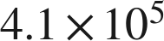

6. 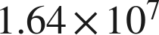

Real quantities.
7. Write each quantity in scientific notation.
a. Earth's beaches hold about 7,500,000,000,000,000,000 grains of sand.

b. A distance of about 39,900,000,000,000 km.

c. A computer displays a population as 1.2E7. Write it in standard form.

8. Complete each comparison.
a. How many times larger is 8.2 than 4.1?

b. How many times larger is  than 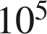?

c. How many times larger is 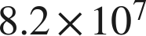 than ?

9. Answer each question.
a. About 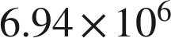 people visited one theme park in a year, and about 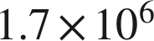 visited another. About how many times larger is the first number? Round to the nearest whole number.

b. China's population is about 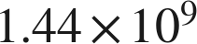 and Mexico's is about 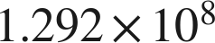. About how many times larger is China's? Round to the nearest tenth.

10. Which of the following is greater? Explain how you know.
a. 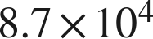 or 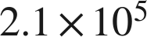

b. 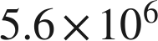 or 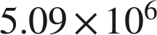

11. Which is 71,000,000 written in scientific notation?
○ A. 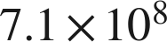
○ B. 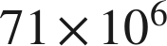
○ C. 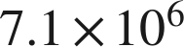
○ D. 

12. Select ALL of the expressions that are equal in value to 6,200,000.
□ A. 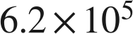
□ B. 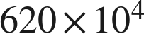
□ C. 
□ D. 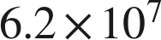
□ E. 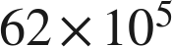
□ F. 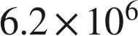

13. In question 12, only one of the four equal expressions is written in scientific notation. Which one is it, and why are the other three not?

